Submitted By: Aiman Ismail

Task 1: Model Evaluation
The first task involved evaluating three deep learning models—CNN, MobileNetV2, and ResNet50—using the same chest X-ray test dataset. The trained .keras models were loaded and tested on unseen images after resizing them to 224 × 224 pixels and normalizing the pixel values. The performance of each model was measured using test accuracy and test loss, which indicate the model's classification performance and prediction error on unseen data.
Model | Test Accuracy | Test Loss
CNN | 75.48% | 2.4188
MobileNetV2 | 87.18% | 0.2755
ResNet50 | 63.78% | 0.5923

Among the three models, MobileNetV2 achieved the highest test accuracy (87.18%) and the lowest test loss (0.2755), indicating the best overall performance. CNN showed moderate results, while ResNet50 achieved the lowest accuracy on the test dataset.
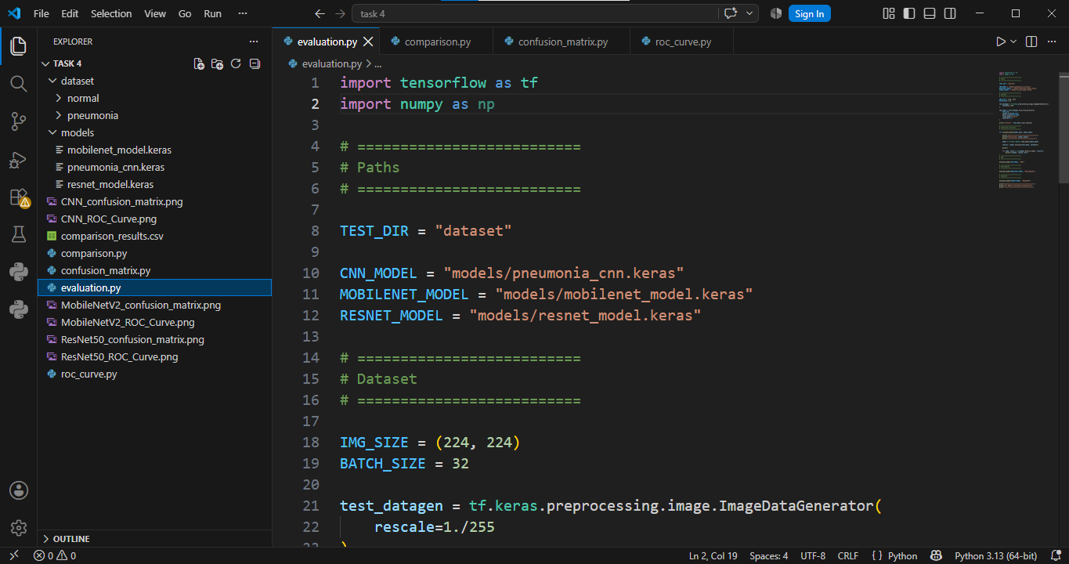
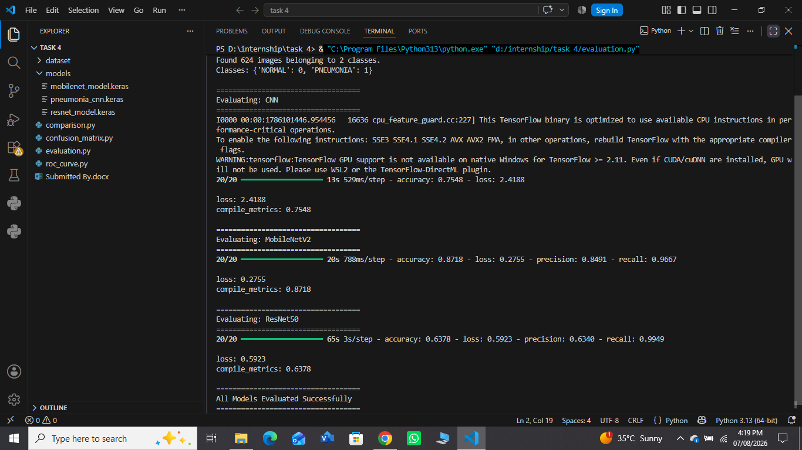

Task 2: Model Comparison
The second task compared the performance of the three models using Accuracy, Precision, Recall, and F1-score. These evaluation metrics provide a comprehensive assessment of the classification performance by measuring overall correctness, prediction reliability, the ability to identify positive cases, and the balance between precision and recall.
Model | Accuracy | Precision | Recall | F1-score
CNN | 75.48% | 72.15% | 98.97% | 83.46%
MobileNetV2 | 87.18% | 84.91% | 96.67% | 90.41%
ResNet50 | 63.78% | 63.40% | 99.49% | 77.45%

The comparison results show that MobileNetV2 achieved the highest accuracy, precision, and F1-score, making it the best-performing model overall. Although ResNet50 achieved the highest recall, its lower accuracy and precision indicate more false positive predictions. Overall, MobileNetV2 provided the most balanced classification performance.
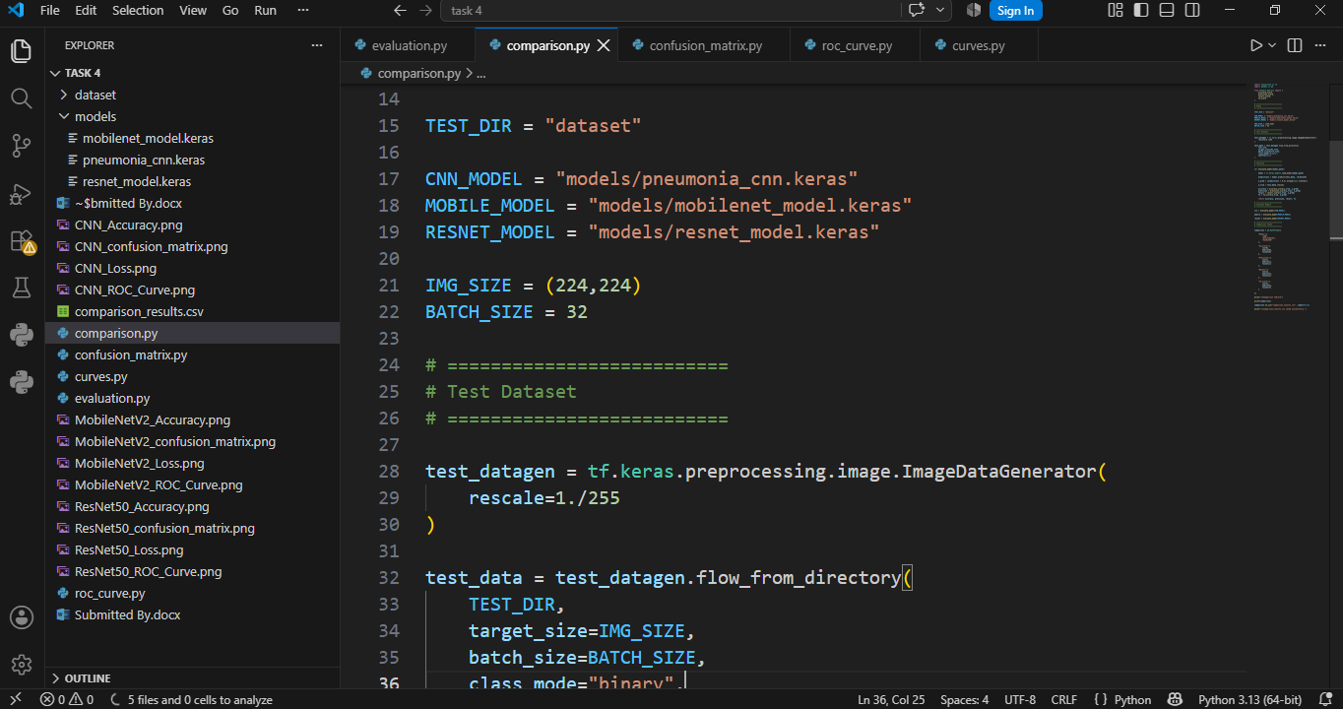
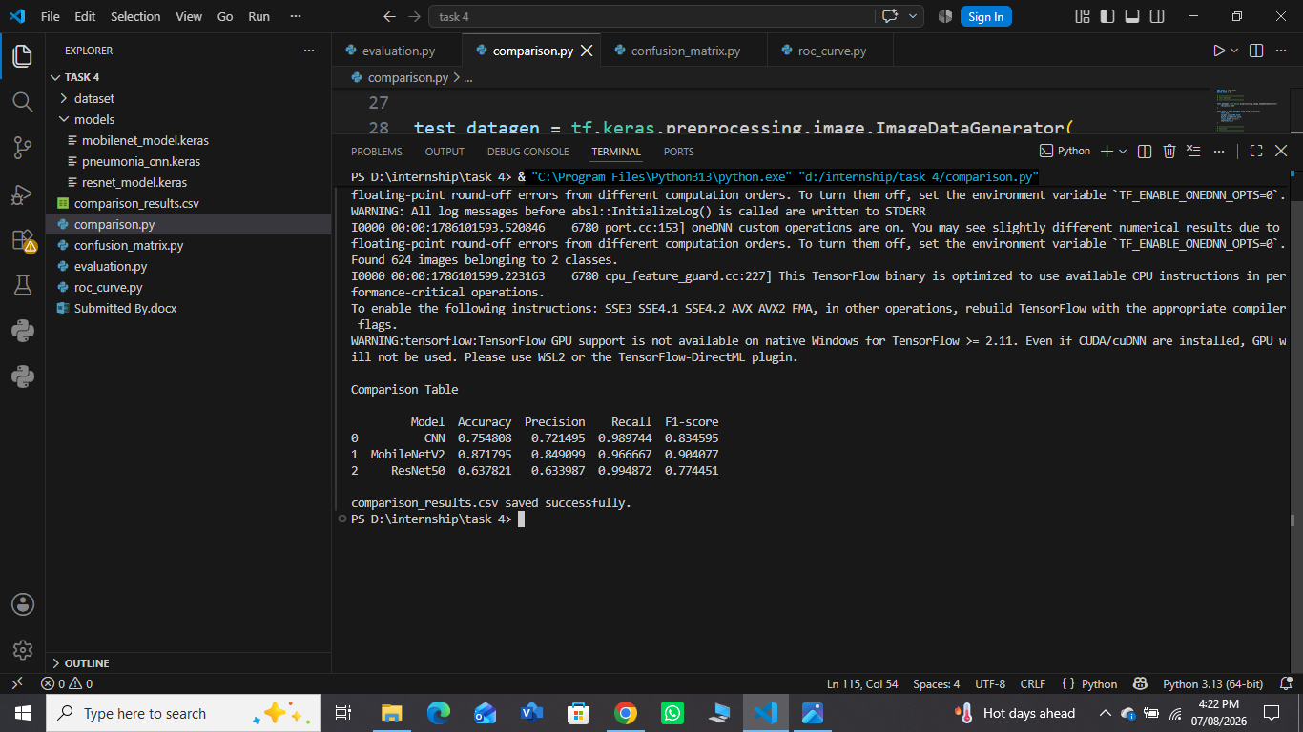

Task 3: Performance Visualization
The third task focused on visualizing the performance of the three models using training and validation accuracy curves, training and validation loss curves, confusion matrices, and ROC curves. These visualizations were generated to analyze the learning process during training and evaluate the classification performance on the test dataset.
The training accuracy of all three models increased steadily, while the training loss decreased throughout the training process, indicating successful learning. The confusion matrices illustrated the classification performance of each model, and the ROC curves demonstrated their ability to distinguish between Normal and Pneumonia images. Overall, MobileNetV2 showed the most stable learning behaviour and produced the best classification performance among the evaluated models.
CNN:
Accuracy:
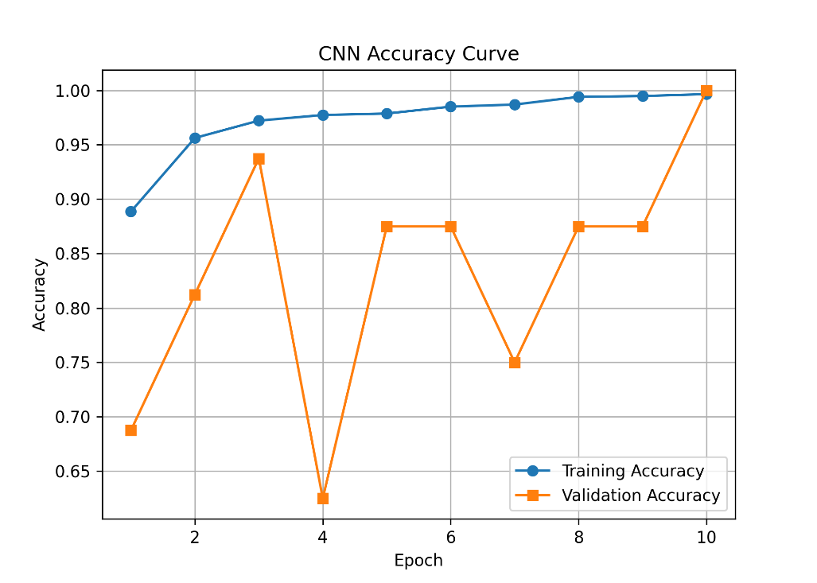
Loss:
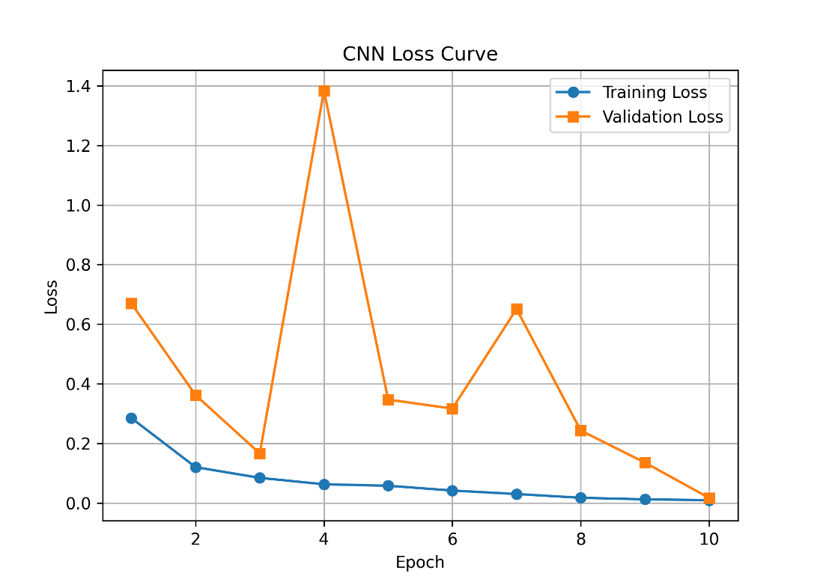
Confusion Matrix:
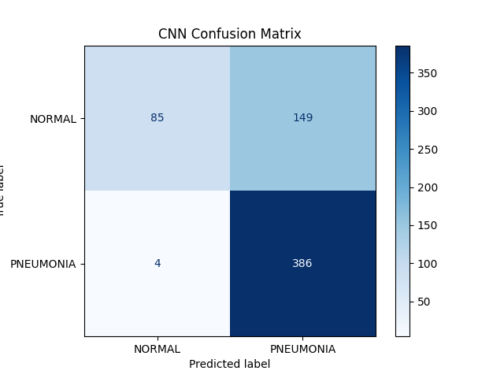
ROC Curve:
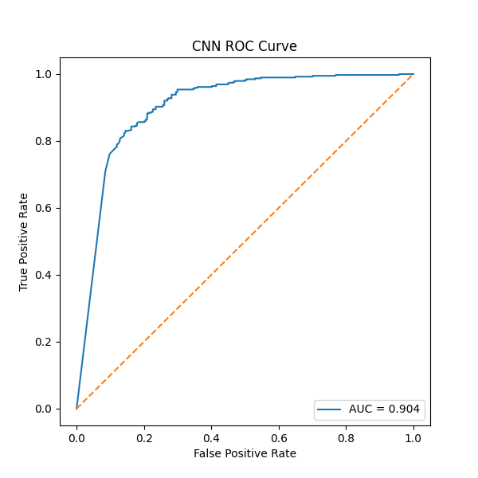

MobileNetV2:
Accuracy:
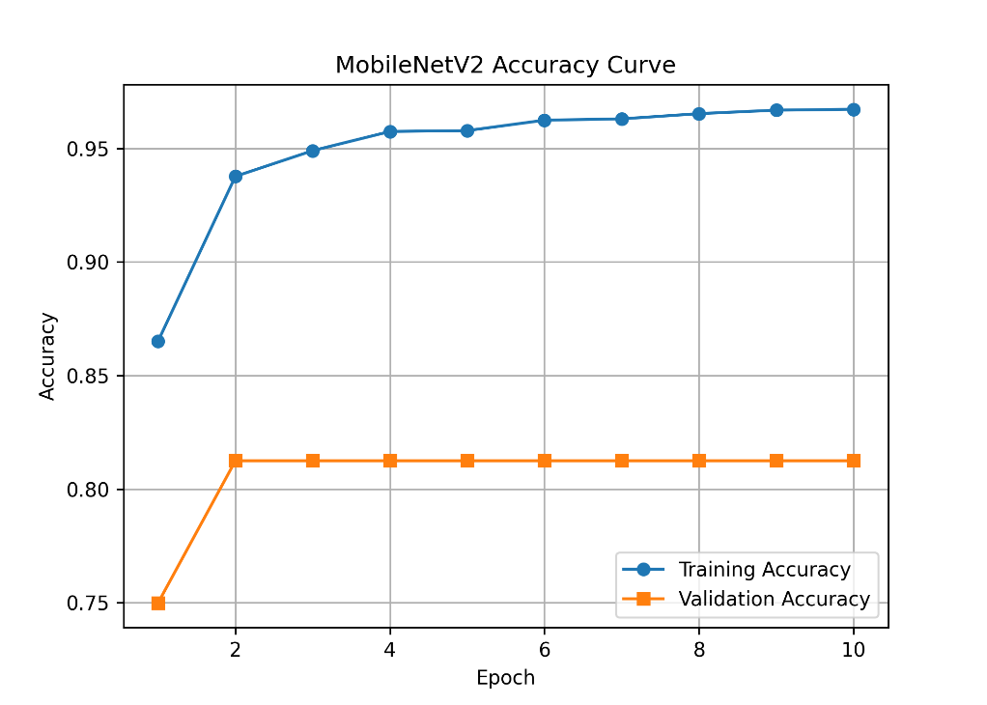
Loss:
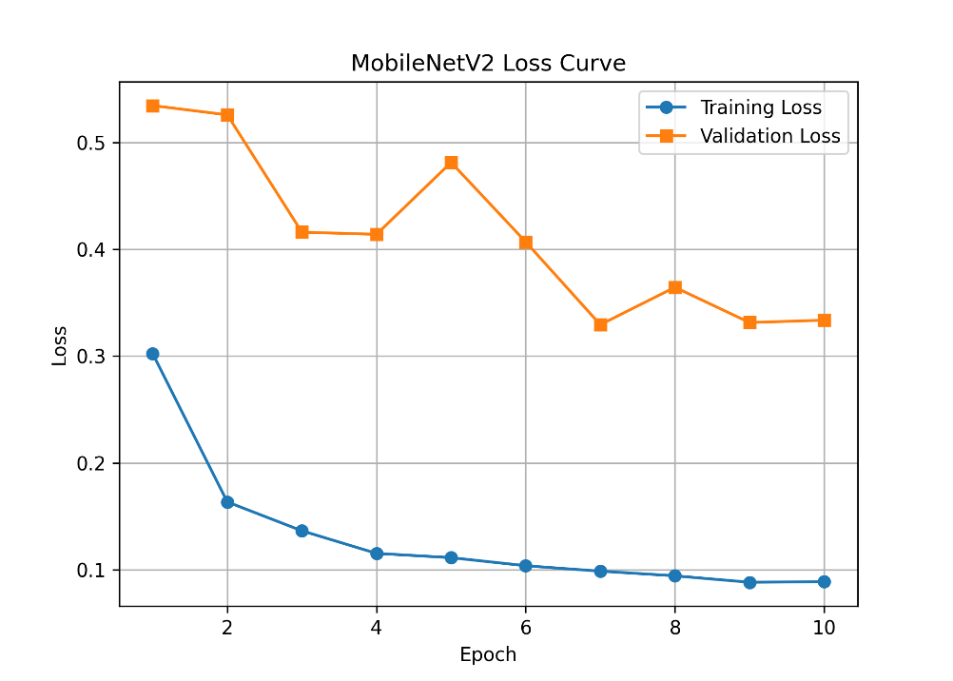
Confusion Matrix:
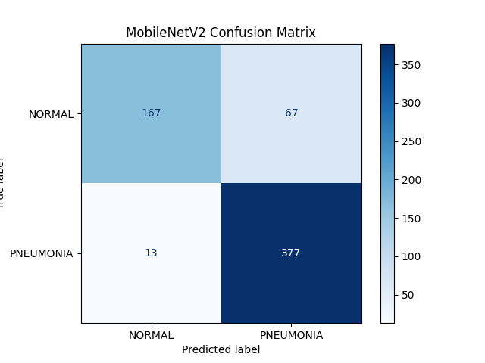
ROC Curve:
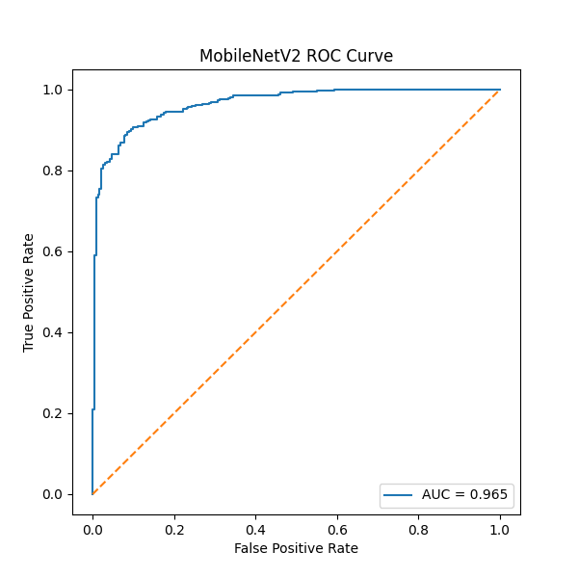

ResNet50:
Accuracy:
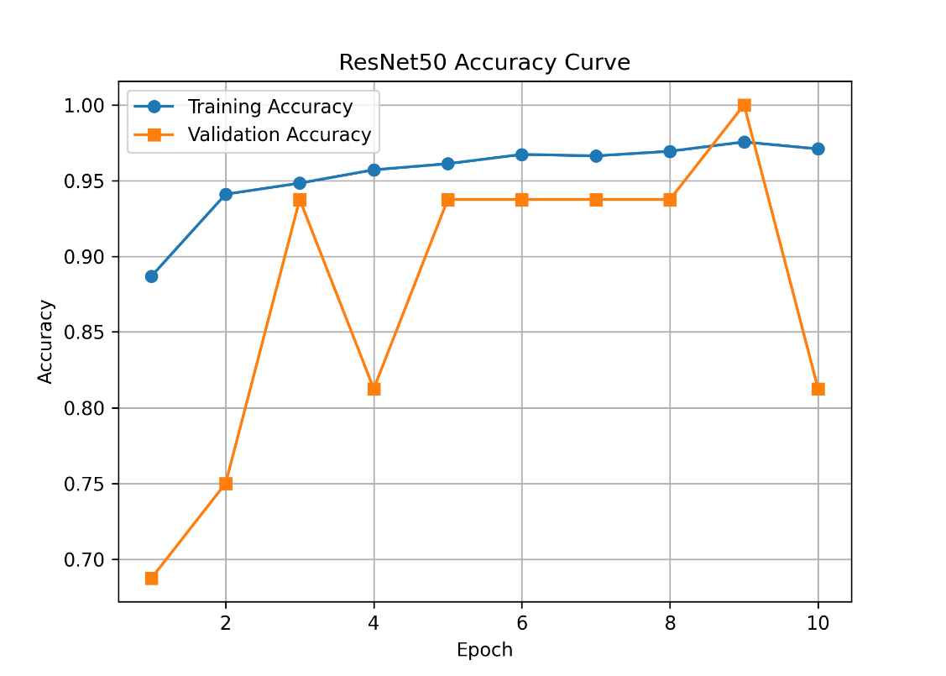
Loss:
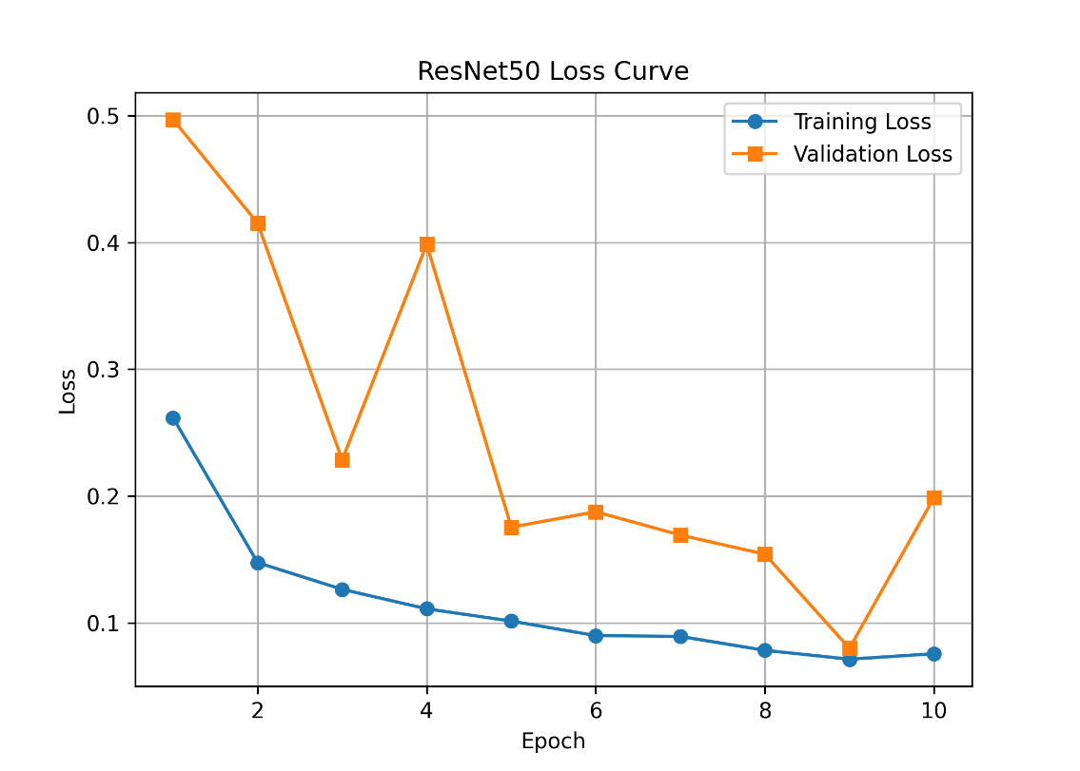
Confusion Matrix:
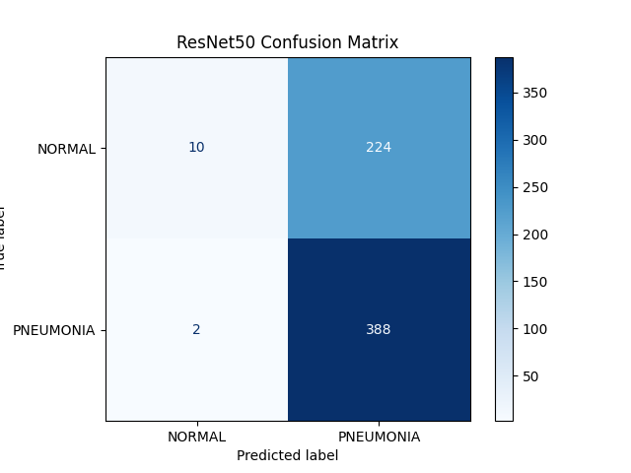
ROC Curve:
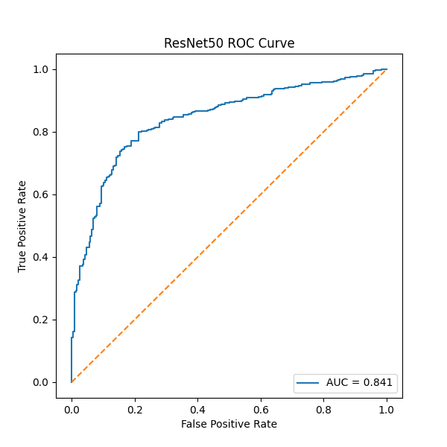
Task 4: Best Model Analysis

Description
After evaluating and comparing the performance of the three deep learning models, MobileNetV2 was identified as the best-performing model for chest X-ray image classification. The selection was based on the evaluation metrics obtained during testing, including Accuracy, Precision, Recall, and F1-score, along with the graphical analysis obtained from the accuracy curves, loss curves, confusion matrices, and ROC curves.
Model | Accuracy | Precision | Recall | F1-score
CNN | 75.48% | 72.15% | 98.97% | 83.46%
MobileNetV2 | 87.18% | 84.91% | 96.67% | 90.41%
ResNet50 | 63.78% | 63.40% | 99.49% | 77.45%
The comparison results show that MobileNetV2 achieved the highest accuracy, precision, and F1-score, while maintaining a high recall. Although ResNet50 achieved the highest recall, its lower accuracy and precision indicate that it produced more false positive predictions. Therefore, considering all evaluation metrics together, MobileNetV2 demonstrated the most balanced and reliable performance and was selected as the best model.

Why MobileNetV2 Performed Better
MobileNetV2 outperformed CNN and ResNet50 due to its efficient network architecture and effective feature extraction capabilities. As a transfer learning model pre-trained on the ImageNet dataset, MobileNetV2 has already learned useful visual features that can be adapted to medical image classification tasks. This allows the model to recognize important patterns in chest X-ray images more effectively than a basic CNN.
The training and validation accuracy curves showed that MobileNetV2 learned consistently throughout the training process, while the loss curves demonstrated a steady reduction in prediction error. The confusion matrix also indicated that the model correctly classified a larger number of chest X-ray images compared to the other models. In addition, the ROC curve showed excellent class discrimination, further confirming the reliability of the model.
Overall, MobileNetV2 achieved the highest classification accuracy while maintaining a good balance between precision, recall, and F1-score, making it the most suitable model for this study.

Advantages of MobileNetV2
The MobileNetV2 model offers several advantages for chest X-ray image classification:
- It achieved the highest overall accuracy (87.18%), indicating superior classification performance.
- It produced the highest precision (84.91%), reducing the number of false positive predictions.
- The model obtained the highest F1-score (90.41%), demonstrating a balanced relationship between precision and recall.
- It maintained a high recall (96.67%), allowing it to correctly identify most pneumonia cases.
- The training and validation curves showed stable learning with decreasing loss over successive epochs.
- MobileNetV2 has a lightweight architecture that requires fewer computational resources than many deep learning models while still providing high classification performance.
- It is suitable for real-world medical image classification because it combines high accuracy with computational efficiency.

Limitations of MobileNetV2
Although MobileNetV2 achieved the best overall performance, it still has some limitations:
- A small number of chest X-ray images were still misclassified during testing.
- The model's performance depends on the quality and diversity of the training dataset.
- Performance may decrease when tested on images collected from different hospitals or imaging devices.
- Like most deep learning models, MobileNetV2 requires sufficient computational resources during training.
- Additional improvements could be achieved by increasing the size of the dataset, applying more advanced data augmentation techniques, or fine-tuning the pretrained layers.
Conclusion
Three deep learning models—CNN, MobileNetV2, and ResNet50—were successfully evaluated using the same chest X-ray test dataset. Their performance was assessed using multiple evaluation metrics, including Accuracy, Precision, Recall, F1-score, Confusion Matrix, ROC Curve, and training performance curves.
The experimental results demonstrated that MobileNetV2 achieved the highest overall performance with an accuracy of 87.18%, precision of 84.91%, recall of 96.67%, and F1-score of 90.41%. The performance visualizations further showed that MobileNetV2 learned effectively during training and maintained stable validation performance. Although CNN produced satisfactory results and ResNet50 achieved the highest recall, MobileNetV2 provided the most balanced performance across all evaluation metrics.
Based on the overall experimental analysis, MobileNetV2 was selected as the most suitable model for chest X-ray image classification. Its combination of high accuracy, balanced performance metrics, and efficient architecture makes it an appropriate choice for assisting in the detection of pneumonia from chest X-ray images.

Comparison Table
Model | Parameters | Accuracy | Training Time
Basic CNN | ~11.2 M | 75.48% | 10 minutes
MobileNetV2 | ~2.42 M | 87.18% | 13 minutes
ResNet50 | ~23.85 M | 63.78% | 18 minutes

